Capstone Project – Battle of the neighbourhoods

# Comparison of cities in the Netherlands

## Data

The data that is needed to answer the question on comparable cities with lower house prices is derived from different sources.

A list of the biggest cities in the Netherlands can be retrieved from <https://wikikids.nl/Lijst_van_grote_Nederlandse_steden>. This site holds a list with all cities with more than 50.000 residents plus one other city (Middelburg) as that is the capitol of a county (Zeeland).

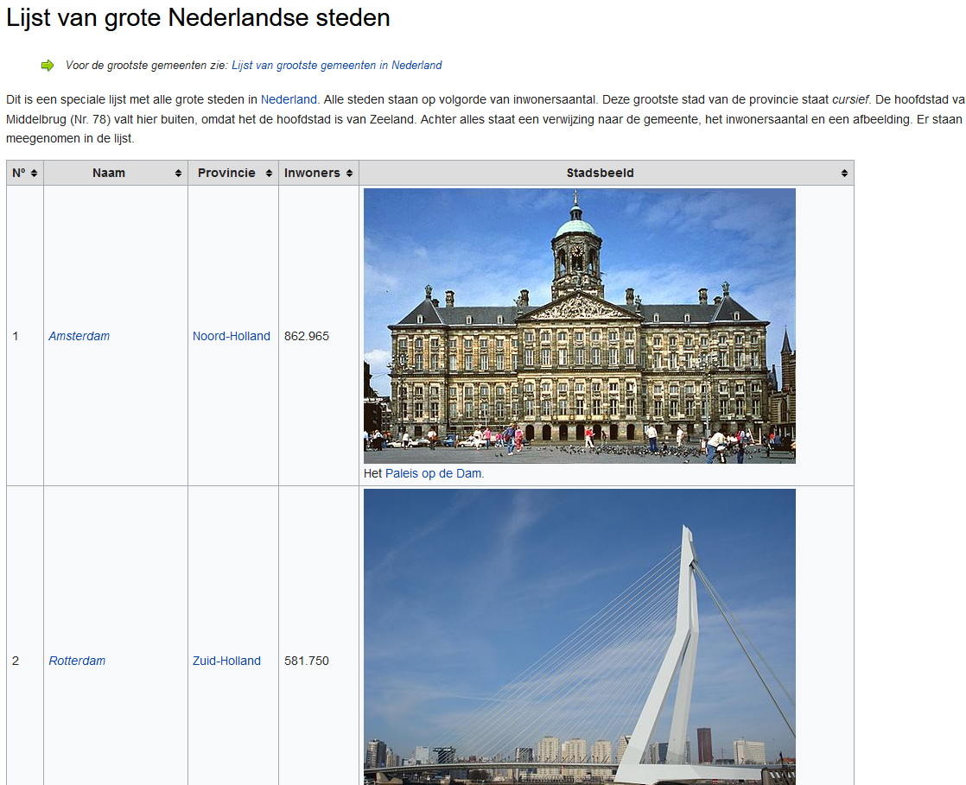

An excel file with the house prices per square meters over the last years can be retrieved from <https://www.huizenzoeker.nl/woningmarkt/download/woningmarkt-gemeenten.xls?d=20210221>

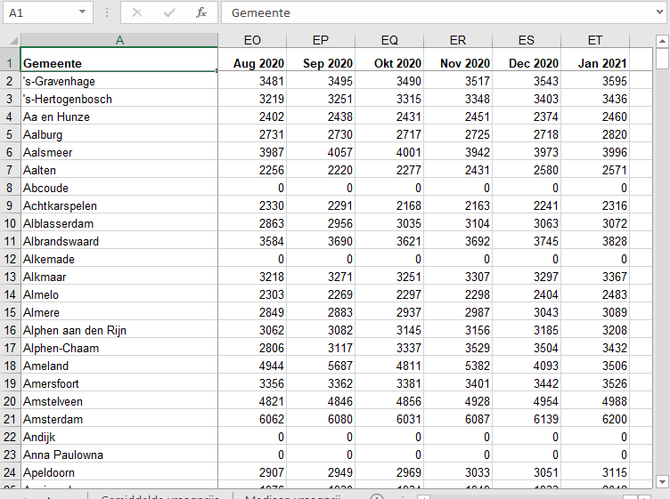

Next to that we need of course data from foursquare on restaurants and bars. Per city the categories for restaurants and bars are queried and added to the data retrieved from the other sites. The correct categories can be found on foursquare <https://developer.foursquare.com/docs/build-with-foursquare/categories> . This data will then be used to cluster cities together. Within those clusters they will be sorted on house price per square meter.